LAB221 Assignment | Type: | Short Assignment
 | Code: | J2.S.P0120
 | LOC: | 50
 | Slot(s): | 1

Title
Edit tree node using combo box
Background Context
In fact, sometime we can also need to perform custom editing of any item in a tree control. JTree supports three techniques for editing tree nodes.
- The easiest is to simply call the setEditable(value) method and set the value to be true
In this mode, the tree values are editable using a simple text editor.
- The second technique is to create a real custom editor for the tree, and this is what we will do in the EditTreeExample.java example below.
- The third technique for tree editing is to replace the DefaultCellEditor() reference in EditTreeExample.java with a class that implementsCellEditor. Refer to the online Swing documentation for details about the CellEditor implementation

Program Specifications
Create a program to allow user edit all nodes in a tree, values are used to update nodes get from a list
Function details:

- Create a tree
- Edit a node base on a list of values stored in a combo box
Expectation of User interface:
The screen should be as:

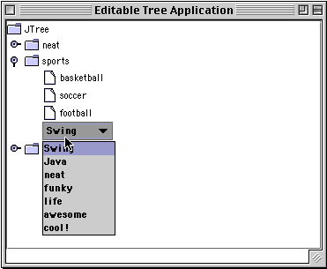

Guidelines

